**OneCLick ScriptRunner Application**

**Objective :-**

This Application can run multiple scripts in one go and create word document and report for every application.

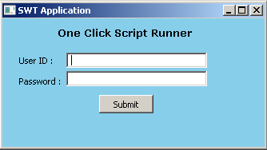

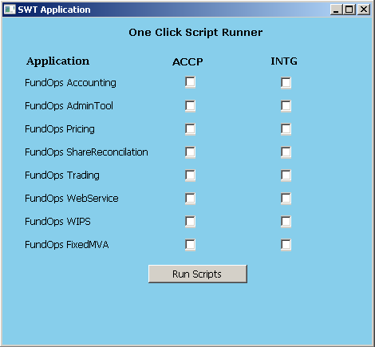

**Description :-**

This application contains 8 FundOps Applications in two regions ACCP & INTG. To run multiple scripts we have to select the checkbox of the application according to region INTG and ACCP then, Click on **Run Scripts** button. This application creates word document and report each time when we run script.

Steps To Configure OneClick ScriptRunner application:-

1. Place **ScriptRunner Application** Folder **in H Drive**



**ScriptRunner Application** Folder Contains :

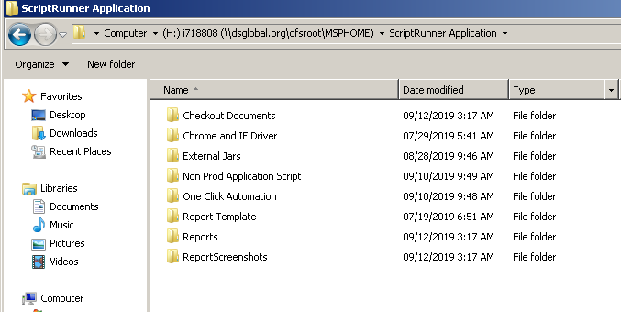

In **Checkout Documents folder** we have word documents. In these word documents we have all the screenshot taken while running application script.

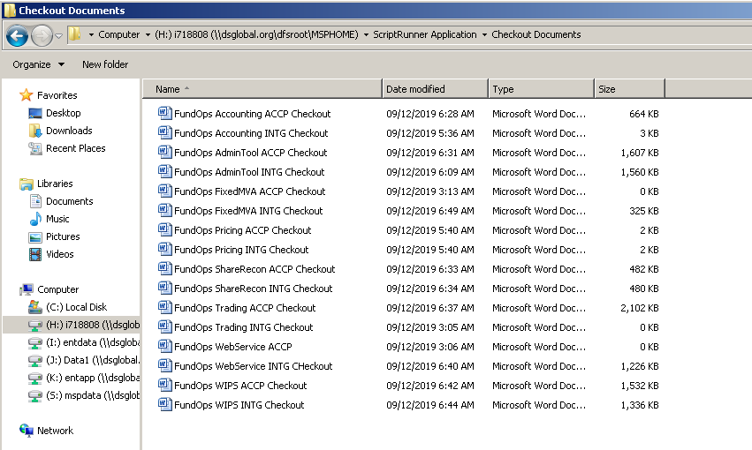

In **Reports folder** we have report of the applications for which we have run scripts.

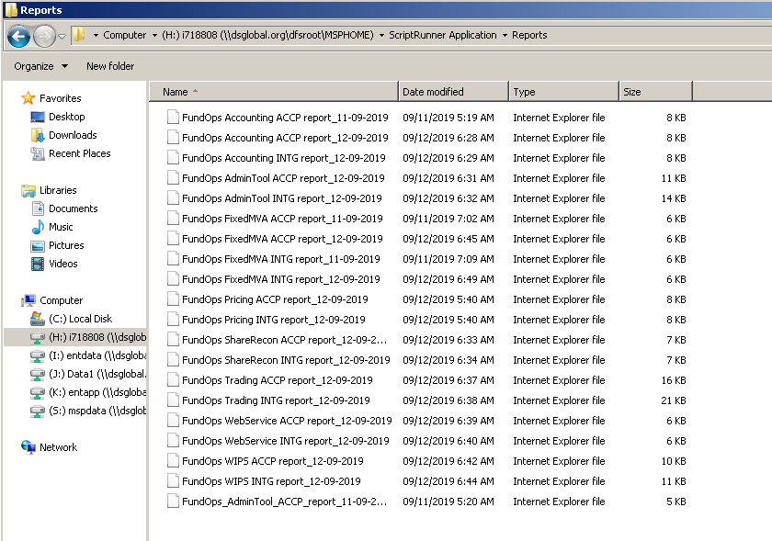

To Run this application we have to place jar in **C Drive** the to launch this application we have to open **CMD** and write below command on CMD

java –jar ScriptRunnerFundOps.jar

Then Click on **Enter.**



**Advantage:-**

1. This application reduces 50% effort of testers.
2. User can directly launch automation scripts without launching Eclipse.